D r . Y u & A s s o c i a t e s
David H. Yu, D.D.S, M.S. | Nicole S. Litizzette, D.D.S., M.S.
4201 Bee Caves Road, Ste. C-211 Austin, TX 78746 | (512) 306-8822
PRE-OPERATIVE SEDATION/ANESTHESIA CHECKLIST
Patient Name: ______ __ DOB: ____ Date: _______

Referral: _________________________________

Sedation Level: Nitrous Oxide Level 1 2 3 4

Medical History:
Medical History Review __ _________
_____________________________________________________
Medication Review _____________________________________________________
_____________________________________________________
Medical Consult/Clearance Needed N/A Y Recv’d Modification (ie: Meds, Recs) N Y
NKDA Medication Allergies:
SOC Hx TOB ______pk-yrs EtOH _______ Illicit Drug Use _________Last used?_______
Previous Surgical/Anesthesia Complications: N Y _____________________________________________________
Family Surgical/Anesthesia Complications: N Y ____________________

Physical Exam:
ASA Classification 1 2 3 4
***NPO status and Vitals (BP, HR, EKG, Auscultation) recorded in the Sedation Record***

Anesthesia Exam:
Mallampati Score I II III IV
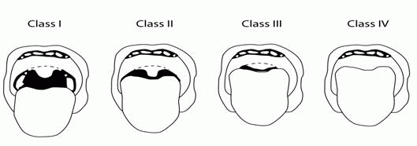
Snoring: Yes No Sleep Apnea: Yes No

Pre-procedure equipment readiness check: Confirmed by (initials): /
Pre-procedure treatment review: Confirmed by (initials): /
Written & verbal pre/post-op instructions: Patient Parent Legal Guardian Caregiver
Confirmed by (initials): /
Special Considerations for high-risk: _____________ _______________
_______________
Reason for omission of any item above: _______________
Pre-procedure verification of above information: Confirmed by (sedation provider’s initials):

